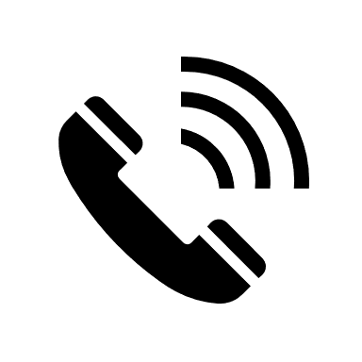
(260)490-1007 precisiondrivingfw@gmail.com
Q: When can I start scheduling drive times?
A: Once you have your permit and class has started.
*See other info sheet for more information.

precision driving

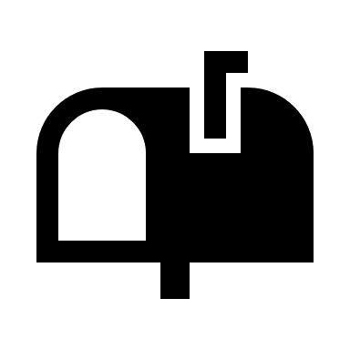
(260)490-1008 www.myprecisiondriving.com
8828 Coldwater Rd Fort Wayne, IN 46825
FAQ’s
About Class: (IN PERSON)
Q: How many hours is class?
Q: How many hours do I need to drive before I get my license?
A: 40 day hours and 10 night hours.
*See info about ROADREADY
A: 30 hours.

Q: What if I miss a day?
A: You will need to make it up in another session.

Q: Do I need a Driver’s manual before class?
A: No, we will provide one on the first day of class.

Q: What percentage do I need to get in class to pass?
A: 80% or more.

About the Permit:
Q: When Can I get my permit?
A: A permit can be obtained if:
- You are 15 years old;
- Your Drivers ED is paid in full;
- It is less than 21 days before class starts.
(In- person only)
- You pick-up a CDE form at Precision Driving’s office.
*Getting your permit before start of class is not necessary. You only need it before
starting your drive times.
Q: Where do I get my permit?
A: At the BMV

Q: Do I have to take a written test at the BMV?
A: Yes, the class is designed to help you prepare for the
test.

Q: Will I have to take the written test again to get my
license?
A: No.

Q: How many drive lessons do I get and how long are they?
A: You complete 6 lessons and they are 1 hour long each.
Q: Does my 6th hour include my drive test?
A: No.

Q: Can I take my test with Precision?
A: Yes, there is an additional $30 fee.

